**PROJECT JARVIS**

# Project Report

***Submitted in partial fulfillment for the award of the degree of***

**BACHELOR OF TECHNOLOGY**

**In**

## COMPUTER SCIENCE ENGINEERING

**(V th SEMESTER)**

**2016 - 2020 Batch**

**APJ ABDUL KALAM TECHNOLOGICAL UNIVERSITY**

**By**

**DON C JOHN (SHR16CS034)**



**NOVEMBER 2018**

**DEPARTMENT OF COMPUTER SCIENCE & ENGG.**

**SAHRDAYA COLLEGE OF ENGINEERING AND TECHNOLOGY KODAKARA, THRISSUR**



# BONAFIDE CERTIFICATE

This is to certify that the project report titled “**PROJECT JARVIS”**

is the bonafide work of **DON C JOHN (SHR16CS034)** during their fifth semester in partial fulfillment of the requirements of the APJ Abdul Kalam Technological University, under our supervision.

**PROJECT GUIDE COORDINATOR HEAD OF THE DEPARTMENT**

**Ms. Linnet Tomy**  **Mrs. Anila Thomas Mr. Krishnadas J**

**Assistant Professor Assistant Professor Assistant Professor**

**Kodakara**

**9-11-2018**

**ACKNOWLEDGEMENT**

We would like to express our immense gratitude and profound thanks to all those who helped us to make this project a great success. We express our gratitude to the almighty God for all the blessings endowed on us.

We submit this report in regard with the project done as a part of the fifth semester curriculum. We acknowledge our Sahrdaya college of engineering and technology for giving us this opportunity to do our project.

We would like to express our thanks to Executive Director **Rev.Fr. George Pareman,** Joint Director **Dr. Sudha George Valavi** and Principal **Dr. Nixon Kuruvilla** for providing us with such a great opportunity.

We express our wholehearted gratitude to **Mr. Krishnadas J,** Head of the Department, CSE who was a source of constant inspiration and suggestions throughout the project work. We extend our sincere gratitude to our project coordinator **Mrs. Anila Thomas,** Assistant Professor and our project guide **Ms. Linnet Tomy**, Assistant Professor for leading the way for the completion of the Project. We would like to extend our appreciation to all other faculty members for their help and advices.

Every project is successful due to the effort of many people. Our thanks and appreciations go to all our peers who had given us their valuable advice and support and pushed us into successfully completing this project.

**INSTITUTIONAL VISION**

To train the youth to be the leaders of tomorrow with apt skills, deep rooted sense of social responsibility, strong ethical values and with a global outlook to face the challenges of changing world.

**INSTITUTIONAL MISSION**

With a high calibre faculty and an excellent infrastructure, we promote academic excellence, absolute discipline and sound practical exposure.

**QUALITY POLICY**

We at Sahrdaya are committed to provide Quality Technical Education through continual improvement and by inculcating Moral & Ethical values to mould into Vibrant Engineers with high Professional Standards.

We impart the best education through the support of competent & dedicated faculties, excellent infrastructure and collaboration with industries to create ambience of excellence.

**Departmental Vision**

|  |
| --- |
| To evolve as a national level Center of Excellence in academics and to research with the aim of imparting contemporary knowledge in the field of Computer Science and Engineering. |

**Departmental Mission**

|  |
| --- |
| 1. Have state of art infrastructure and resources for teaching and research. 2. Impart relevant technical knowledge, skills and attributes along with values and ethics. 3. Enhance research quality and creativity through innovative teaching learning methodologies. 4. Mold Computer Science Engineering Professionals in synchronization with the dynamic industry requirements, worldwide. 5. Inculcate essential leadership qualities coupled with commitment to the society. |

|  |  |
| --- | --- |
|  | **Programme Educational Objectives (PEOs)** |
|  |  |
| PEO1 | Take up challenging careers in suitable corporate, business or educational |
|  | sectors across the world, in multi-cultural work environment. |
|  |  |
| PEO2 | Continuously strive for higher achievements in life keeping moral and ethical |
|  | values such as honesty, loyalty, good relationship and best performance, aloft. |
|  |  |
| PEO3 | Be knowledgeable and responsible citizens with good team-work skills, |
|  | competent leadership qualities and holistic values. |
|  |  |

|  |  |
| --- | --- |
|  | **Programme Specific Outcomes (PSOs)** |
|  |  |
| PSO1 | To nurture students with technically inquisitive attitude so that any real- world |
|  | problem could be tackled with a problem-solving perspective, finding a suitable |
|  | mathematical model with strong fundamental technological concepts to solve |
|  | and apply to rapid growing arena of computer technology. |
|  |  |
| PSO2 | To develop professionals with excellent exposure to the latest technologies to |
|  | design high quality products unique in innovation, technology, software, |
|  | security, hardware and usefulness; making high impact on society, business |
|  | and technology. |
|  |  |
| PSO3 | To enhance knowledge in practical implementation of technology with regard |
|  | to parallelism, virtualization of networks, scientific analysis and modeling, |
|  | visualization, natural language processing, digital synthesis of data and its |
|  | manipulation, wireless and mobile communication, storage and retrieval of |
|  | huge amount of data etc. |
|  |  |

|  |  |
| --- | --- |
|  | **Programme Outcomes (POs)** |
|  |  |
| PO1 | Engineering knowledge: Apply the knowledge of mathematics, science, |
|  | engineering fundamentals, and an engineering specialization to the solution of |
|  | complex engineering problems. |
|  |  |
| PO2 | Problem analysis: Identify, formulate, review research literature, and analyze |
|  | complex engineering problems reaching substantiated conclusions using first |
|  | principles of mathematics, natural sciences, and engineering sciences. |
|  |  |
| PO3 | Design/development of solutions: Design solutions for complex engineering |
|  | problems and design system components or processes that meet the specified |
|  | needs with appropriate consideration for the public health and safety, and the |
|  | cultural, societal, and environmental considerations. |
|  |  |
| PO4 | Conduct investigations of complex problems: Use research-based knowledge |
|  | and research methods including design of experiments, analysis and |
|  | interpretation of data, and synthesis of the information to provide valid |
|  | conclusions. |
|  |  |
| PO5 | Modern tool usage: Create, select, and apply appropriate techniques, resources, |
|  | and modern engineering and IT tools including prediction and modelling to |
|  | _________________________________________________________________complex engineering activities with an understanding of the limitations. |
|  | Modern tool usage: Create, select, and apply appropriate techniques, resources, |
|  |  |
| PO6 | The engineer and society: Apply reasoning informed by the contextual |
|  | knowledge to assess societal, health, safety, legal and cultural issues and the |
|  | consequent responsibilities relevant to the professional engineering practice. |
|  |  |
| PO7 | Environment and sustainability: Understand the impact of the professional |
|  | engineering solutions in societal and environmental contexts, and demonstrate |
|  | the knowledge of, and need for sustainable development. |
|  |  |
| PO8 | Ethics: Apply ethical principles and commit to professional ethics and |
|  | responsibilities and norms of the engineering practice. |
|  |  |
| PO9 | Individual and team work: Function effectively as an individual, and as a |
|  | member or leader in diverse teams, and in multidisciplinary settings. |
|  |  |
| PO10 | Communication: Communicate effectively on complex engineering activities |
|  | with the engineering community and with society at large, such as, being able to |
|  | comprehend and write effective reports and design documentation, make |
|  | effective presentations, and give and receive clear instructions. |
|  |  |
| PO11 | Project management and finance: Demonstrate knowledge and understanding of |
|  | the engineering and management principles and apply these to one’s own work, |
|  | as a member and leader in a team, to manage projects and in multidisciplinary |
|  | environments. |
|  |  |

**COURSE OBJECTIVES**

|  |
| --- |
| * To understand the engineering aspects of design with reference to simple products * To foster innovation in design of products, processes or systems * To develop design that add value to products and solve technical problems |

**COURSE OUTCOMES**

|  |  |
| --- | --- |
| **CO1** | Think innovatively on the development of components, products, processes or technologies in the field computer science. |
| **CO 2** | Analyze the problem requirements and arrive workable design solutions. |
| **CO 3** | Design a prototype with respect to the current technologies. |
| **CO 4** | Think and design products which meets the needs of the society |

**Mapping of COs with POs**

|  |  |  |  |  |  |  |  |  |  |  |  |  |
| --- | --- | --- | --- | --- | --- | --- | --- | --- | --- | --- | --- | --- |
|  | **PO1** | **PO2** | **PO3** | **PO4** | **PO5** | **PO6** | **PO7** | **PO8** | **PO9** | **PO10** | **PO11** | **PO12** |
| **CO1** | **3** |  | **3** |  | **3** |  |  |  | **3** |  |  | **2** |
| **CO2** |  | **3** |  | **2** |  |  |  |  |  |  |  |  |
| **CO3** |  |  | **3** | **2** | **3** |  | **2** |  | **3** | **3** | **3** |  |
| **CO4** |  |  |  |  |  | **3** | **2** | **1** |  |  |  |  |

**#1 – Weak correlation 2- Moderate correlation 3- Substantial correlation**

**PROJECT OBJECTIVES**

|  |  |
| --- | --- |
| 1 | Suggest better plan and action with accordance with robot’s artificial intelligence. |
| 2 | Helps in our daily chaos and act as personnel assistance. |
| 3 | Robot will be connected to most of our social media accounts. |

**PROJECT OUTCOMES**

The student will be able to

|  |  |
| --- | --- |
| **PR1** | Understand the concept of Emotional AI. |
| **PR2** | Relevance of Emotional AI in Computer Science & Engineering. |
| **PR3** | Build a website for the AI. |
| **PR4** | Know different software like OpenCV, selenium, PyCharm. |

**Mapping of PRs with COs**

|  |  |  |  |  |
| --- | --- | --- | --- | --- |
|  | **CO1** | **CO2** | **CO3** | **CO4** |
| **PR1** | 3 | 2 | 2 | 2 |
| **PR2** | 3 | 3 | 1 | 2 |
| **PR3** | 2 | 3 | 2 | 2 |
| **PR4** | 3 | 2 | 3 | 3 |
| **Avg** | 2.75 | 2.5 | 2 | 2.25 |

**# 1 - Weak Correlation 2 - Moderate Correlation 3 - Substantial Correlation**

**ABSTRACT**

Success is the result of perfection, hard work, learning from failure, loyalty & persistence. Most of the robots designed nowadays need human interferences in some way or the other. Considering this problem, we decided to design a robot that can automate life of the user with his feeling or willing. It comes with visual recognition, speech in Malayalam, voice assistance, Wi-Fi access, fully structured robot with surveillance, remote control and so on. We are creating a social intelligent smart robot which can talk with you in different platforms and it can react to your instant chats on social media accounts it will suggest better plan and action with accordance with its artificial intelligence. We hope that this project can be utilized by future and the present generations.

**TABLE OF CONTENT**

**CHAPTER NO TITLE PAGE NO**

**ACKNOWLEDGEMENT i**

**INSTITUTION VISION, MISSION ii**

**AND QUALITY POLICY**

**DEPARTMENTAL VISION, MISSION, iii**

**PEOs, PO AND PSOs**

**ABSTRACT viii**

**LIST OF FIGURES xi**

**LIST OF ABBREVIATION xii**

**1. INTRODUCTION 1**

**2. LITERATURE SURVEY 2**

2.1 EXISTING SYSTEM 2

2.1.1 ASIMO 2

2.1.2 CHATBOT 2

2.1.3 HOME AUTOMATION CONTROL 3

2.1.4 QUERY BOT 3

2.2 DISADVANTAGES OF EXISTING SYSTEM 3

2.3 PROPOSED SYSTEM 3

2.4 ADVANTAGES OF PROPOSED SYSTEM 4

**3. DESIGN AND DEVELOPMENT 5**

3.1 SYSTEM ARCHITECTURE 5

3.2 USE CASE DIAGRAM 6

3.3 CLASS DIAGRAM 7

3.4 HARDWARE REQUIREMENTS 8

3.4.1 RASPBERRY PI 8

3.4.2 ARDUINO UNO 8

3.4.3 SERVO MOTOR 9

3.4.4 IR SENSOR 10

3.4.5 TOUCH SENSOR 10

3.4.6 NODE MCU 11

3.4.7 OLED 12

3.4.8 MQ2 SENSOR 13

**4. SYSTEM ENVIORNMENT 14**

4.1 PYCHARM 14

4.2 ARDUINO IDE 14

4.3 PHPMYADMIN 15

4.4 CPANEL 15

4.5 OPENCV 16

**5. SYSTEM DEVELOPMENT 17**

5.1 MODULE DESCRIPTION 17

**6. CONCLUSION 18**

**REFERENCE**

**LIST OF FIGURES**

**FIGURE NO: NAME OF FIGURE PAGE NO:**

3.1 System Architecture 5

3.2 Use Case Diagram 6

3.3 Class Diagram 7

3.4 Raspberry PI 8

3.5 Arduino UNO 9

3.6 IR Sensor 10

3.7 Touch Sensor 11

3.8 Node MCU 11

3.9 Gas Sensor 13

**LIST OF ABBREVATIONS**

**ABBREVATION EXPANSIONS**

OLED Organic Light-Emitting Diode

PC Personal Computer

OS Operating System

RPA Robotic Process Automation

IDE Integrated Development Environment

LCD Liquid Crystal Display

**CHAPTER 1**

**INTRODUCTION**

Today robots are expected to collaborate with people should be able to interact with them in the most natural way. This involves significant perceptual and interactive skills, operating in a coordinated fashion. Consider a social gathering scenario where a humanoid is expected to possess certain social skills. It should be able to analyze a populated space, to localize people, and to determine whether they are looking at the robot and are speaking to it. Humans appear to solve these tasks routinely by integrating the often complementary information provided by multi-sensory data processing, from 3D object positioning and sound-source localization to gesture recognition. Understanding the world from unrestricted sensorial data, recognizing people’s intentions and behaving like them are extremely challenging problems.

Robots excel at performing pre-programmed tasks. They work well in highly controlled environments with well-defined objects. They cannot, however, cope with the complexities of most real-world environments, which are too nuanced and complicated to be summarized within a limited set of specifications. Thanks to recent developments in sensor and networking technology, groups of robots can now be networked in order to share information, learn from their peers and work together, but these smart feed forward systems currently operate in isolation from each other. Each system is built independently, and if it is decommissioned, all its learning is lost.

Considering this problem, we decided to design a robot that can automate life of the user with his feeling or willing. It comes with visual recognition, speech in Malayalam, voice assistance, Wi-Fi access, fully structured robot with surveillance, remote control and so on. We hope that this project can be utilized by future generations.

**CHAPTER 2**

**LITERATURE SURVEY**

**2.1 EXISTING SYSTEMS**

There are about 4 types of systems are existing now. They are ASIMO, Chatbot, Home Automation, and Query Bot.

**2.1.1 ASIMO**

Honda began developing humanoid robots in the 1980s, including several prototypes that preceded ASIMO. It was the company's goal to create a walking robot. E0 was the first bipedal (two-legged) model produced as part of the HONDA P series, which was an early experimental line of self-regulating, humanoid walking robot with wireless movements created between 1986 and 1993. This was followed by the HONDA P series of robots produced from 1993 through 1997. The research made on the E- and P-series led to the creation of ASIMO. Development began at Honda's Wako Fundamental Technical Research Center in Japan in 1999 and ASIMO was unveiled in October 2000.

**2.1.2 CHATBOT**

A chatbot (also known as a Smart bot, Talkbot, Chatterbot, Bot, IM bot, interactive agent, Conversational interface or Artificial Conversational Entity) is a computer program or an artificial intelligence which conducts a conversation via auditory or textual methods. Such programs are often designed to convincingly simulate how a human would behave as a conversational partner, thereby passing the Turing test. Chatbots are typically used in dialog systems for various practical purposes including customer service or information acquisition. Some chatterbots use sophisticated natural language processing systems, but many simpler systems scan for keywords within the input, then pull a reply with the most matching keywords, or the most similar wording pattern, from a database.

**2.1.3 HOME AUTOMATION CONTROL**

Home automation is building automation for a home, called a smart home or smart house. A home automation system will control lighting, climate, entertainment systems, and appliances. It may also include home security such as access control and alarm systems. When connected with the Internet, home devices are an important constituent of the Internet of Things.

**2.1.4 QUERY BOT**

Beyond sending commands in private messages or groups, users can interact with your bot. If queries are enabled, users can call your bot by typing its username and a query in the text input field in any chat. The query is sent to your bot in an update. This way, people can request content from your bot in any of their chats, groups, or channels without sending any messages at all.

* 1. **DISADVANTAGES OF EXISTING SYSTEM**
* Voice in English
* Social media connectivity
* Productivity less
* Lack of Artificial Intelligence
* Electronic automation
* IVR problems
* Networking Integration Issues

**2.3 PROPOSED SYSTEM**

Robotic process automation is an emerging form of business process automation technology based on the notion of software robots or artificial intelligence (AI) workers. We are creating a social intelligent smart robot which can talk with you in different platforms and it can react to your instant chats on social media accounts it will suggest better plan and action with accordance with its artificial intelligence. We all know Success is the result of perfection, hard work, learning from failure, loyalty & persistence. why not we make a smart success Here we bring out smart with RPA (Robotic Process Automation) with combination of Neural Networking & Deep Learning So we make out a Robot which would enhance your social life to the next level.

**2.4 ADVANTAGES OF PROPOSED SYSTEM**

* Voice in mother tongue.
* Complete home automation enabled.
* Display using OLED.
* Social media connectivity.
* Includes Emotional AI.

**CHAPTER 3**

**DESIGN AND DEVELOPMENT**

**3.1 SYSTEM ARCHITECTURE**

The Figure 3.1 depicts the architecture of the system which works in various platforms. The system is connected to most of the social media accounts like WhatsApp, FB and Gmail so that we can interact with the robot very easily and will be useful for many people. The robot can recognize some of our gestures correctly and communicate with us. The system consist of a server which provide us twenty four hour service.it consist of motors for the movements and different sensors are connected for different purpose.

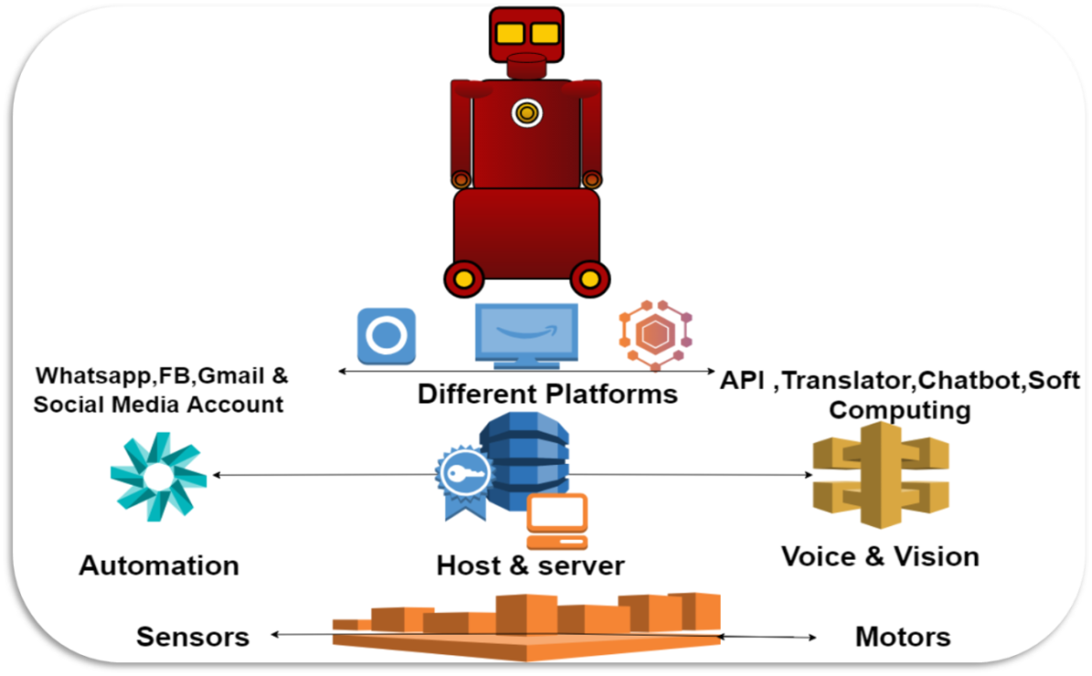

Figure 3.1 System Architecture

**3.2 USE CASE DIAGRAM**

Use case diagrams are usually referred to as behavior diagrams used to describe a set of actions (use cases) that some system or systems (subject) should or can perform in collaboration with one or more external users of the system (actors). Each use case should provide some observable and valuable result to the actors or other stakeholders of the system.

Use case diagrams are in fact twofold - they are both behavior diagrams, because they describe behavior of the system, and they are also structure diagrams - as a special case of class diagrams where classifiers are restricted to be either actors or use cases related to each other with associations.

In this Figure 3.2 we can see that more than one user can interact with the robot at the same time. It helps in the automation of home. User can interact with the robot using the chatbot .it consists of an OLED display. The robot is based on the Emotional AI. The system is connected with most of the social media accounts.

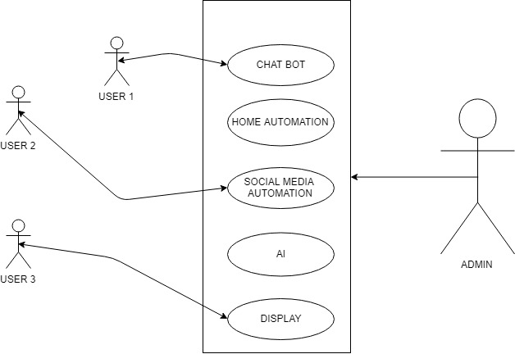

Figure 3.2: Use Case Diagram

**3.3 Class Diagram**

In software engineering, a class diagram in the Unified Modeling Language (UML) is a type of static structure diagram that describes the structure of a system by showing the system's classes, their attributes, operations (or methods), and the relationships among objects. It is used for general conceptual modeling of the systematic of the application, and for detailed modeling translating the models into programming code.

Class diagrams can also be used for data modeling. The classes in a class diagram represent both the main elements, interactions in the application, and the classes to be programmed. The Figure 3.3 shows the class diagram of Jarvis which consist of two objects that is user and the robot. The user can call and interact with the robot and the robot can move in different direction, recognize some of the gestures and voice and can connect to various social media accounts of the user.

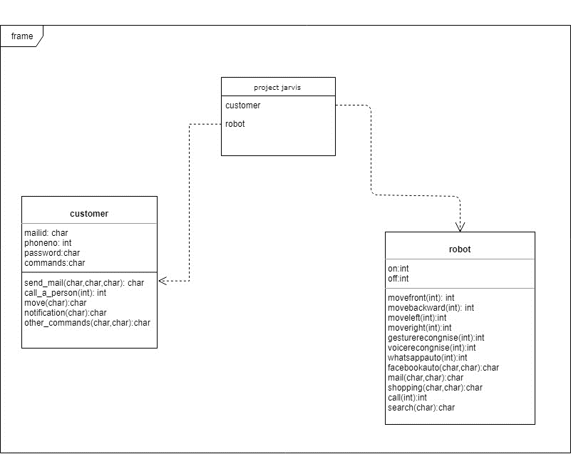

Figure 3.3: Class Diagram

**3.4 HARDWARE DESCRIPTION**

Some of the hardware components which are used in this project are described below.:

**3.4.1 Raspberry pi**

The Figure 3.4 depicts Raspberry Pi is a series of small single-board computers developed in the United Kingdom by the Raspberry Pi Foundation to promote teaching of basic computer science in schools and in developing countries. The original model became far more popular than anticipated, selling outside its target market for uses such as robotics. It does not include peripherals (such as keyboards and mice) and cases. However, some accessories have been included in several official and unofficial bundles.

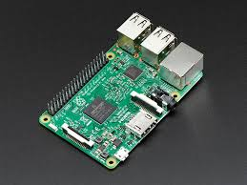

Figure 3.4 Raspberry pi

**3.4.2 Arduino Uno**

The Arduino UNO is an open-source microcontroller board based on the Microchip ATmega328P microcontroller and developed by Arduino.cc. The board is equipped with sets of digital and analog input/output (I/O) pins that may be interfaced to various expansion boards (shields) and other circuits. The Figure 3.5 board has 14 Digital pins, 6 Analog pins, and programmable with the Arduino IDE (Integrated Development Environment) via a type B USB cable. It can be powered by a USB cable or by an external 9 volt battery, though it accepts voltages between 7 and 20 volts. It is also similar to the Arduino Nano and Leonardo. The hardware reference design is distributed under a Creative Commons Attribution Share-Alike 2.5 license and is available on the Arduino website. Layout and production files for some versions of the hardware are also available. "Uno" means one in Italian and was chosen to mark the release of Arduino Software (IDE) 1.0.

The Uno board and version 1.0 of Arduino Software (IDE) were the reference versions of Arduino, now evolved to newer releases. The Uno board is the first in a series of USB Arduino boards, and the reference model for the Arduino platform. The ATmega328 on the Arduino Uno comes preprogrammed with a bootloader that allows uploading new code to it without the use of an external hardware programmer. It communicates using the original STK500 protocol. The Uno also differs from all preceding boards in that it does not use the FTDI USB-to-serial driver chip. Instead, it uses the Atmega16U2 (Atmega8U2 up to version R2) programmed as a USB-to-serial converter.

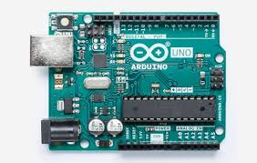

Figure 3.5: Arduino UNO

**3.4.3 Servo Motor**

A servomotor is a closed-loop servomechanism that uses position feedback to control its motion and final position. The input to its control is a signal (either analogue or digital) representing the position commanded for the output shaft. The motor is paired with some type of encoder to provide position and speed feedback. In the simplest case, only the position is measured. The measured position of the output is compared to the command position, the external input to the controller. If the output position differs from that required, an error signal is generated which then causes the motor to rotate in either direction, as needed to bring the output shaft to the appropriate position. As the positions approach, the error signal reduces to zero and the motor stops. The very simplest servomotors use position-only sensing via a potentiometer and bang-bang control of their motor; the motor always rotates at full speed (or is stopped). This type of servomotor is not widely used in industrial motion control, but it forms the basis of the simple and cheap servos used for radio-controlled models.

More sophisticated servomotors use optical rotary encoders to measure the speed of the output shaft and a variable-speed drive to control the motor speed. Both of these enhancements, usually in combination with a PID control algorithm, allow the servomotor to be brought to its commanded position more quickly and more precisely, with less overshooting.

**3.4.4 IR Sensor**

An infrared sensor is an electronic device that emits in order to sense some aspects of the surroundings. An IR sensor can measure the heat of an object as well as detects the motion. The Figure 3.6 shows a sensor which measures only infrared radiation, rather than emitting it that is called as a passive IR sensor. Usually in the infrared spectrum, all the objects radiate some form of thermal radiations. These types of radiations are invisible to our eyes that can be detected by an infrared sensor. The emitter is simply an IR LED (Light Emitting Diode) and the detector is simply an IR photodiode which is sensitive to IR light of the same wavelength as that emitted by the IR LED. When IR light falls on the photodiode, the resistances and these output voltages, change in proportion to the magnitude of the IR light received.

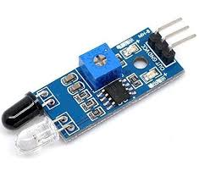

Figure 3.6: IR Sensor

**3.4.5 Touch Sensor**

The Figure 3.7 shows a touch sensor, primarily works when an object or individual gets in physical contact with it. Unlike a button or other more manual control, touch sensors are more sensitive, and are often able to respond differently to different kinds of touch such as tapping, swiping and pinching. Touch sensors are used in consumer tech devices such as smartphones and tablet computers.

Typically, touch sensors are used as a means to take input from the user. Each physical stroke that a touch sensor records is sent to a processing unit/software that processes it accordingly. For example, when navigating through a smartphone or using an application, the touch sensor captures the human touches or the applied pressure across the screen. Each interaction with the user across the screen might have a different meaning for the device and/or the application.

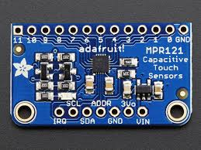

Figure 3.7: Touch Sensor

**3.4.6 Node MCU**

NodeMCU is an open source LUA based firmware developed for ESP8266 Wi-Fi chip. By exploring functionality with ESP8266 chip, NodeMCU firmware comes with ESP8266 Development board/kit i.e. NodeMCU Development board.

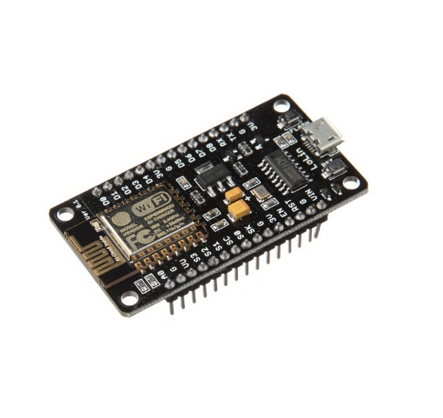

Figure 3.8: NodeMcu

NodeMCU is open source platform, their hardware design is open for edit/modify/build. NodeMCU Dev Kit/board consist of ESP8266 Wi-Fi enabled chip. The ESP8266 is a low-cost Wi-Fi chip developed by Espressif Systems with TCP/IP protocol. For more information about ESP8266, you can refer ESP8266 Wi-Fi Module. There is Version2 (V2) available for NodeMCU Dev Kit i.e. NodeMCU Development Board v1.0 (Version2), which usually comes in black colored PCB.

**3.4.7 OLED**

An organic light-emitting diode (OLED) is a light-emitting diode (LED) in which the emissive electroluminescent layer is a film of organic compound that emits light in response to an electric current. This organic layer is situated between two electrodes; typically, at least one of these electrodes is transparent. OLEDs are used to create digital displays in devices such as television screens, computer monitors, and portable systems such as smartphones, handheld game consoles and PDAs. A major area of research is the development of white OLED devices for use in solid-state lighting applications. There are two main families of OLED: those based on small molecules and those employing polymers. Adding mobile ions to an OLED creates a light-emitting electrochemical cell (LEC) which has a slightly different mode of operation. An OLED display can be driven with a passive-matrix (PMOLED) or active-matrix (AMOLED) control scheme. In the PMOLED scheme, each row (and line) in the display is controlled sequentially, one by one, whereas AMOLED control uses a thin-film transistor backplane to directly access and switch each individual pixel on or off, allowing for higher resolution and larger display sizes. An OLED display works without a backlight because it emits visible light. Thus, it can display deep black levels and can be thinner and lighter than a LCD. In low ambient light conditions (such as a dark room), an OLED screen can achieve a higher contrast ratio than an LCD, regardless of whether the LCD uses cold cathode fluorescent lamps or an LED backlight.

**3.4.8 MQ2 Gas Sensor**

The Figure 3.8 shows a Grove - Gas Sensor (MQ2) module which is useful for gas leakage detection (home and industry). It is suitable for detecting H2, LPG, CH4, CO, Alcohol, Smoke or Propane. Due to its high sensitivity and fast response time, measurement can be taken as soon as possible. The sensitivity of the sensor can be adjusted by potentiometer.

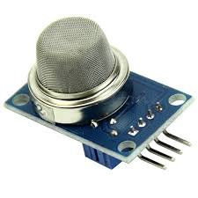

Figure 3.9:MQ2 Gas sensor

**CHAPTER 4**

**SOFTWARE ENVIORNMENT**

**4.1 PYCHARM**

PyCharm is an integrated development environment (IDE) used in computer programming, specifically for the Python language. It is developed by the Czech company JetBrains. It provides code analysis, a graphical debugger, an integrated unit tester, integration with version control systems (VCSes), and supports web development with Django. PyCharm is cross-platform, with Windows, macOS and Linux versions. The Community Edition is released under the Apache License, and there is also Professional Edition with extra features, released under a proprietary license.

**4.2 ARDUINO IDE**

The Arduino IDE is a cross-platform application (for Windows, macOS, Linux) that is written in the programming language Java. It is used to write and upload programs to Arduino board. The source code for the IDE is released under the GNU General Public License, version 2. The Arduino IDE supports the languages C and C++ using special rules of code structuring. The Arduino IDE supplies a software library from the Wiring project, which provides many common input and output procedures. User-written code only requires two basic functions, for starting the sketch and the main program loop, that are compiled and linked with a program stub main() into an executable cyclic executive program with the GNU toolchain, also included with the IDE distribution. The Arduino IDE employs the program avrdude to convert the executable code into a text file in hexadecimal encoding that is loaded into the Arduino board by a loader program in the board's firmware.

**4.3 PHP MYADMIN**

phpMyAdmin is a free and open source administration tool for MySQL and MariaDB. As a portable web application written primarily in PHP, it has become one of the most popular MySQL administration tools, especially for web hosting services.

**4.4 CPANEL**

cPanel is an online Linux-based web hosting control panel that provides a graphical interface and automation tools designed to simplify the process of hosting a web site to the website owner or the "end user". cPanel utilizes a three-tier structure that provides capabilities for administrators, resellers, and end-user website owners to control the various aspects of website and server administration through a standard web browser. While cPanel is limited to managing a single website, the server administration panel of which cPanel is a part is known as WHM, short for Webhost Manager. In addition to the GUI, cPanel also has command line and API-based access that allows third-party software vendors, web hosting organizations, and developers to automate standard System Administration Processes. WHM is designed to function either as a dedicated server or virtual private server. The latest WHM version supports installation on CentOS, Red Hat Enterprise Linux (RHEL), and Cloud Linux OS. cPanel 11.30 is the last major version to support FreeBSD.

Application-based support includes Apache, PHP, MySQL, PostgreSQL, Perl, and BIND (DNS). Email-based support includes POP3, IMAP, and SMTP services. cPanel is accessed via https on port 2083, while WHM is accessed via https on Port 2087.Once installed, WHM cannot be easily removed. WHM's FAQ states that the best way to uninstall WHM is by reformatting the server. However, uninstall guides are available online for expert server administrators who do not wish to reformat their server. Similarly, it should only be installed on a freshly installed operating system with minimal prior configuration

**4.5 OPENCV**

OpenCV (Open Source Computer Vision) is a library of programming functions mainly aimed at real-time computer vision. Originally developed by Intel, it was later supported by Willow Garage then Itseez (which was later acquired by Intel). The library is cross-platform and free for use under the open-source BSD license. OpenCV supports the deep learning frameworks TensorFlow, Torch / PyTorch and Caffe.

OpenCV is written in C++ and its primary interface is in C++, but it still retains a less comprehensive though extensive older C interface. There are bindings in Python, Java and MATLAB/OCTAVE. The API for these interfaces can be found in the online documentation. Wrappers in other languages such as C#, Perl, Haskell and Ruby have been developed to encourage adoption by a wider audience. All of the new developments and algorithms in OpenCV are now developed in the C++ interface. OpenCV runs on the following desktop operating systems: Windows, Linux, macOS, FreeBSD, NetBSD, OpenBSD. OpenCV runs on the following mobile operating systems: Android, iOS, BlackBerry 10. The user can get official releases from Source Forge or take the latest sources from GitHub. OpenCV uses CMake.

**CHAPTER 5**

**SYSTEM DEVELOPMENT**

**5.1 MODULE DESCRIPTION**

The robot is fully structured, which can move forward, backward, left and right using motors and wheel. Using touch sensor, it can identify if there is any contact with anyone. Computer input devices are indifferent to human contact as there is no reaction from software in the event of making, maintaining or breaking physical contact like touches or releases. Thus, touch sensing input devices offers numerous possibilities for novel interaction techniques. With the help of ultrasonic sensor, it can measure distance or sensing objects are required. We can sense any smell of gas using MQ2 gas sensor and gives us an alert. The robot is fully automated. It is connected to most of the social networking site. It can recognize voice and some of the gestures.it can interact with other person in Malayalam. Since it is an artificial intelligent robot, it can take decision according to the feelings of the user. The user can send a mail with the help of the robot to anyone. It can shop or place order for the user. It stores the data which we received from the outside world and stores in the database and take data from database when needed. It recognizes the obstructions in front of the robot and move accordingly. And it will be displayed in OLED display.

**CHAPTER 6**

**CONCLUSION**

Robotic process automation is an emerging form of business process automation technology based on the notion of software robots or artificial intelligence (AI) workers. Among other technological trends, RPA is expected to drive a new wave of productivity and efficiency gains in the global Labour market. It is said that up to 35% of all jobs may have been automated by 2035.We created smart with RPA with combination of Neural Networking & Deep Learning So we make out a social intelligent smart robot which can talk with you in different platforms and it can react to your instant chats on social media accounts. It will suggest better plan and action with accordance with its artificial intelligence. It also helps us during our daily chaos and act as personnel assistance. The robot can interact in Malayalam language. It is fully automated and connected to most of our social networking sites so we are proposing a system which will be useful for the present and future generation.

**REFERENCES**

[1] www.wikipedia.org

[2] Make your own neural network: a gentle journey through the mathematics

Book by Tariq Rashid

[3] Artificial Intelligence with Python by Prateek Joshi

[4] Gesture Recognition: Principles, Techniques and Applications by Amit Konar,

Sriparna Saha

[5] Owls Guide to HTML & CSS by Tushar Goel.